Database Systems
Lab 8
PL/SQL Programming 2
Version 1.1

Three tables will be used in this session and the script to create and populate them is provided on the shared folder. The file is called ‘author.sql’. Before completing any of these exercises you should run this script in iSQLPlus to create the sample database

The schema used for this session is as follows:

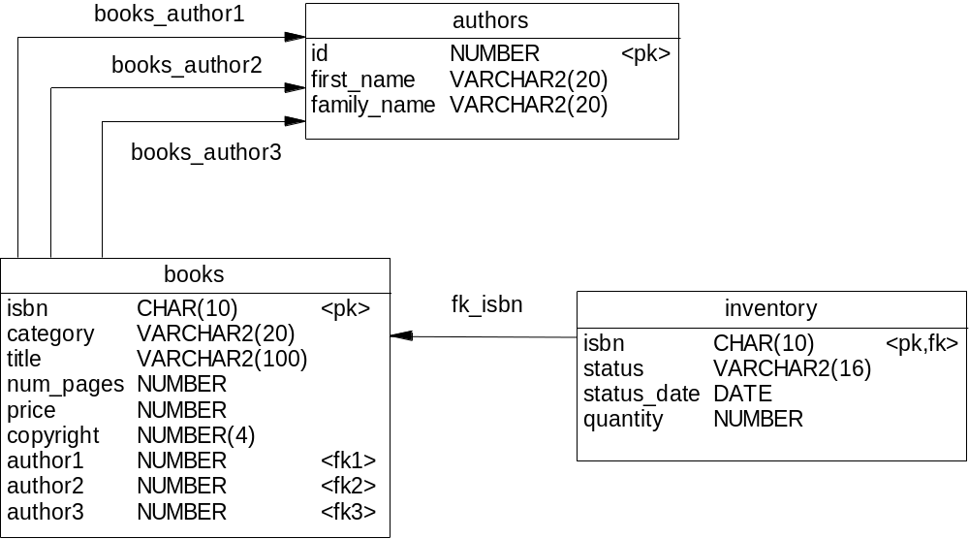

Task (1)
Load and run the following sql script files
- while.sql
- for.sql
- loop.sql
What does each of these programs do? Make brief notes on the differences between the loops.

Task (2)
Write an anonymous block to display ONLY the first 6 titles from ‘books’ table.
Hint: Use a simple cursor and the cursor function %ROWCOUNT.

SET SERVEROUTPUT ON
DECLARE
CURSOR book_cur IS
SELECT isbn, title FROM books;
book_record book_cur%ROWTYPE;

BEGIN
OPEN book_cur;
LOOP
FETCH book_cur INTO book_record;
EXIT WHEN book_cur%ROWCOUNT > 6;
DBMS_OUTPUT.PUT_LINE ('ISBN : ' || book_record.isbn || ' ' || book_record.title);
END LOOP;
CLOSE book_cur;
END;
/

Run the script create2006.sql.

Introduction to PL/SQL Procedures

A procedure is a named PL/SQL block that is created by using a CREATE PROCEDURE statement. When called, or invoked, a procedure performs a sequence of actions. The anatomy of the procedure includes:
- The header: “PROCEDURE getemp IS”
- The declaration section: With variable declarations emp_id and lname
- The executable section: Contains the PL/SQL and SQL statements used to obtain the last name of employee 100. The executable section makes use of the DBMS_OUTPUT package to print the last name of the employee.
- The exception section: Optional and not used in the example

SET SERVEROUTPUT ON;
CREATE OR REPLACE PROCEDURE getemp IS
emp_id employees.employee_id%type;
lname employees.last_name%type;
BEGIN
emp_id := 176;
SELECT last_name INTO lname
FROM EMPLOYEES
WHERE employee_id = emp_id;
DBMS_OUTPUT.PUT_LINE('Last name: '||lname);
END;
/
SHOW ERRORS;

To call a procedure by using an anonymous block, use:

BEGIN
getemp;
END;
/

The procedure called ADD_JOB to insert a new job into the JOBS table. The procedure requires that the job_id and the title of the job is provided using two parameters.

CREATE OR REPLACE PROCEDURE add_job (
jobid jobs.job_id%TYPE,
jobtitle jobs.job_title%TYPE) IS
BEGIN
INSERT INTO jobs (job_id, job_title)
VALUES (jobid, jobtitle);
COMMIT;
END add_job;
/
SHOW ERRORS

Class Work
- Make a script to invoke the procedure with ‘IT_DBA’ as job ID and ‘Database Administrator’ as job title.
- Create a procedure called UPD_JOB to update the job title. Provide the job ID and a new title using two parameters. Include the necessary exception handling if no update occurs.
- IF SQL%NOTFOUND THEN
- RAISE_APPLICATION_ERROR(-20202, 'No job updated.');
- END IF;
- Create a procedure called DEL_JOB to delete a job. Provide an exception handling section so that if there is nothing to delete as ordered.
- IF SQL%NOTFOUND THEN
- RAISE_APPLICATION_ERROR(-20203, 'No jobs deleted.');
- END IF;

